COBBLESTONE PARK LADIES GOLF ASSOCIATION
FEBRUARY & MARCH HAPPENINGS
COBBLESTONE PARK MEMBER EVENT
March 17 at 9AM CPLGA St Paddy's Day tournament/ get together. Meet at 9AM, first tee time 9:24 AM with snacks after play. Mark your calendar and get your "green" ready.
SANDLAPPER ( 4TH TUESDAY, 9:30 AM START)
Contact Lydia Neeley: 828-699-6889, LydWNee@gmail.com
TBD
TEAM MATCH PLAY (9:30 am SHOTGUN BE THERE BY 9am)
Wednesday, March 4th at Cobblestone. Contact is Alice Ward: 803-629-0512(cell) or AWDaisy@aol.com. Alice will send out a request for players.
HANDICAP MATCH PLAY (9:30 am SHOTGUN START BE THERE BY 9)
Contact Rhetta Griffin: 803-337-6438, absolute@truvista.net
TBD
SC SENIOR WOMENS GOLF ASSOCIATION
1st Tournament not until April 9th
WOMENS SC GOLF ASSOCIATION Sign up on line www.wscga.org
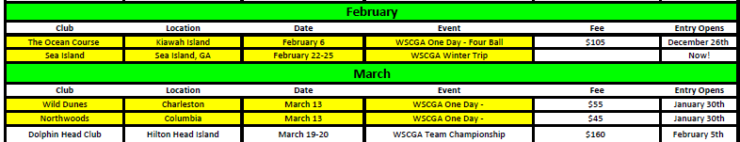

CAROLINAS GOLF ASSOCIATION Sign up on line at www.carolinasgolf.org/Women
Ladies Four-Ball(better ball of two). Entry fee $150/team and includes all golf fees, gross and net prizes and lunch. All events are flighted by Handicap Index.
